SIMATS ENGINEERING
ASSESSMENT TOOL 1

NAME: Siva Dakshitha K REG.NO:192425395
COURSE NAME: COMPUTER NETWORKS COURSE CODE: CSA0703

COURSE OUTCOME COVERED

CO5:
Design network topologies star, mesh, bus, and hybrid using networking devices, transmission media, and cabling standards
(BL2,BL5)

Assessment Tool Weightage: 40%

QUESTIONS: 3 Total Marks:30

Annexure A

Constraint-Based Problem Solving
- A multinational company is opening a new branch office in a remote rural location where high-speed wired internet is unavailable. The office must support cloud-based applications, video conferencing, and secure communication with the headquarters. The company has a limited budget for connectivity but requires uninterrupted business operations. As a network engineer, recommend a suitable internet connection, networking devices, and security mechanisms. Justify your recommendations by considering bandwidth limitations, reliability, cost, and future scalability
ANSWER:
1. Remote Rural Branch Office
Problem Analysis
The company is establishing a branch office in a rural location where high-speed wired broadband is unavailable. However, the office needs reliable internet for cloud applications, video meetings, file sharing, email, and secure communication with headquarters.
The major constraints are:
- No high-speed wired connection
- Limited budget
- Requirement for reliable connectivity
- Requirement for secure communication
- Possibility of future expansion
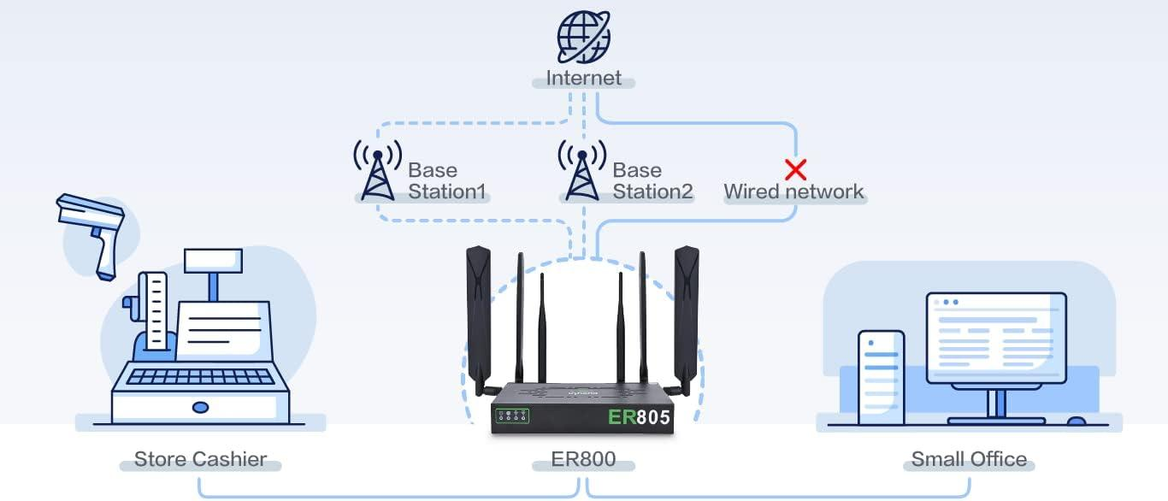
Figure 1: Proposed Network Architecture for Remote Rural Branch Office
Recommended Internet Connection
The recommended primary connection is 4G/5G broadband if sufficient cellular coverage is available.
If cellular connectivity is weak or unstable, satellite internet can be used. A dual-WAN router can support two connections and automatically switch to the backup connection.
Proposed Network
4G/5G Internet
|
[4G/5G Router]
|
[Firewall/Router]
|
[Gigabit Switch]
/ | \
PCs/Laptops Printer Access Point
|
Wi-Fi Devices
|
VPN Tunnel
|
Headquarters
Network Devices
1. 4G/5G Router
Provides internet connectivity using the cellular network.
2. Firewall/Router
Controls incoming and outgoing traffic and provides security.
3. Gigabit Switch
Connects computers, printers, servers, and other wired devices.
4. Wireless Access Point
Provides wireless connectivity to employees.
5. UPS
Provides temporary power to networking equipment during power interruptions.
Security Mechanisms
The branch should use:
- Firewall
- VPN
- WPA3
- Multi-factor authentication
- Strong passwords
- Network segmentation
- Regular software updates
- Antivirus/endpoint protection
A VPN tunnel between the branch and headquarters protects sensitive business communication over the public internet.
Reliability
Because business operations should not stop when the primary connection fails, a backup connection is recommended.
For example:
Primary: 4G/5G
↓
If failure
↓
Backup: Satellite/Second ISP
A dual-WAN router can perform automatic failover.
Bandwidth Consideration
Cloud applications generally require stable internet connectivity. Video conferencing requires more bandwidth than simple email or web browsing.
Therefore, bandwidth should be prioritized for:
- Video conferencing
- Cloud applications
- Business-critical applications
- VPN traffic
Less important activities such as personal streaming can be restricted.
Cost Consideration
Building wired infrastructure in a remote rural area may be expensive. Using existing cellular infrastructure reduces installation costs.
Satellite can be kept as a backup if the budget allows.
Future Scalability
The network should support future:
- Employees
- Computers
- IoT devices
- Access points
- Servers
Requirement | Solution
Connectivity | 4G/5G
Backup | Satellite/second ISP
Security | Firewall + VPN
Wi-Fi | WPA3 Access Point
Reliability | Dual-WAN + UPS
Scalability | Expandable router/switch
- Additional internet connections
A scalable switch and firewall should therefore be selected.
Final Recommendation
A 4G/5G primary connection + backup connection + firewall + VPN + secure Wi-Fi + UPS is a practical solution.
It provides:
Conclusion
The proposed solution provides a balance between bandwidth, reliability, cost, security, and future scalability. It allows the rural branch to access cloud services and communicate securely with headquarters without requiring expensive wired infrastructure.
The three constraint-based network problems demonstrate that network design should always be based on the specific requirements, limitations, and objectives of an organization. A single networking solution cannot be considered suitable for every situation because rural offices, large university campuses, and financial institutions have completely different requirements.
In the first question, the rural branch office faces the major constraint of unavailable high-speed wired internet and a limited budget. A 4G/5G wireless connection with a backup connection, supported by a firewall, VPN, secure Wi-Fi, and UPS, provides a practical solution. This design allows employees to access cloud applications, participate in video conferences, and securely communicate with headquarters. Backup connectivity improves availability and reduces the risk of business interruption. The solution can also be expanded as the branch grows.

- A university plans to provide campus-wide wireless internet access for more than 3,000 students across classrooms, laboratories, libraries, and hostels. The network must support a large number of simultaneous users while minimizing signal interference and ensuring secure access. Due to budget constraints, only a limited number of wireless access points can be deployed. Analyze the requirements and propose an efficient wireless network design, including access point placement, frequency band selection, and authentication methods. Explain how your solution balances coverage, performance, security, and cost.
ANSWER:
2. University Campus-Wide Wireless Network
Problem Analysis
The university needs to provide wireless connectivity to more than 3,000 students across classrooms, laboratories, libraries, hostels, and common areas.
This is a high-density wireless environment.
The major constraints are:
- Thousands of simultaneous users
- Limited number of APs
- Signal interference
- High bandwidth requirements
- Secure authentication
- Limited budget
- Requirement for campus-wide coverage
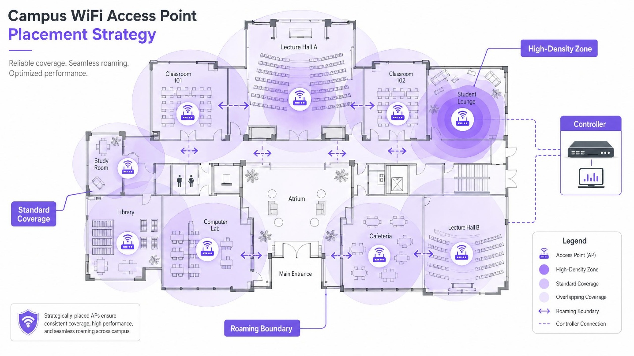

Recommended Technology
A centrally managed Wi-Fi 6/6E network is suitable because it is designed to handle many simultaneous users more efficiently than older Wi-Fi standards.
Proposed Architecture
Internet
|
[Core Router]
|
[Firewall]
|
[Core Switch]
|
[Wireless Controller]
/ | \
AP1 AP2 AP3 ...
/ | \
Classrooms Library Hostels
\ | /
Students
Access Point Placement
APs should not simply be installed at equal distances.
Placement should depend on user density and building structure.
Priority should be given to:
- Large lecture halls
- Computer laboratories
- Libraries
- Hostels
- Classrooms
- Common areas
High-density areas need better capacity rather than simply stronger signal.
Site Survey
Before deployment, a wireless site survey should identify:
- Signal strength
- Dead zones
- Interference
- Number of expected users
- Building walls
- AP locations
- Channel availability
This prevents unnecessary AP deployment and reduces cost.

Frequency Band Selection
2.4 GHz
Advantages:
- Longer range
- Better penetration through obstacles
Disadvantages:
- More interference
- Fewer useful non-overlapping channels
- Lower capacity
It can be used for devices that require greater coverage.
5 GHz
Advantages:
- Higher speeds
- More channels
- Better for high-density environments
It should be the primary band for students and high-performance devices.
6 GHz
Where compatible Wi-Fi 6E/7 devices are available, 6 GHz provides additional spectrum and can reduce congestion.
Recommended Approach
2.4 GHz → Coverage / older devices
5 GHz → Main student traffic
6 GHz → High-performance compatible devices

Interference Management
Wireless interference can seriously reduce performance.
It can be reduced by:
- Proper channel planning
- Using different channels for nearby APs
- Controlling transmission power
- Avoiding unnecessary AP overlap
- Using automatic channel management
- Monitoring wireless performance

Authentication
The university should use:
WPA3-Enterprise
Provides strong wireless security.
802.1X
Allows users to authenticate individually.
Students can use their university credentials rather than sharing a common Wi-Fi password.
Network Segmentation
Different users should be separated using VLANs.
VLAN 10 → Students
VLAN 20 → Faculty
VLAN 30 → Administration
VLAN 40 → Guests
VLAN 50 → IT/Management
This prevents guest or student devices from directly accessing sensitive administrative systems.

Performance Management
A wireless controller can monitor:
- Number of connected users
- AP utilization
- Bandwidth usage
- Signal strength
- Interference
- Failed connections
Load balancing can move users between APs when one AP becomes overloaded.
Cost Optimization
Because the university has a limited AP budget, APs should be concentrated in locations where the largest number of users are present.
Instead of deploying many APs with overlapping coverage, the university can use:
- High-capacity APs
- Proper channel planning
- Centralized management
- Band steering
- Load balancing
Final Recommendation
Requirement | Recommended Solution
Wi-Fi standard | Wi-Fi 6/6E
High-density band | 5 GHz/6 GHz
Extended coverage | 2.4 GHz
Authentication | WPA3-Enterprise + 802.1X
Management | Central controller
Segmentation | VLANs
Interference | Channel planning
AP placement | Based on user density
Conclusion
A centrally managed Wi-Fi 6/6E network with strategic AP placement, proper frequency planning, WPA3-Enterprise authentication, VLAN segmentation, and centralized monitoring can provide reliable campus-wide wireless connectivity while balancing coverage, performance, security, and cost.
In the second question, the university needs to provide wireless connectivity to more than 3,000 students across several buildings and high-density areas. The main challenge is not simply providing coverage, but providing sufficient capacity and performance for many simultaneous users. A centrally managed Wi-Fi 6/6E network, strategic access-point placement, proper channel planning, and the use of 5 GHz/6 GHz bands can reduce congestion and improve performance. WPA3-Enterprise, 802.1X authentication, and VLAN segmentation provide secure access while keeping student, faculty, guest, and administrative traffic separated.

- A financial institution is upgrading its internal computer network to improve cybersecurity while allowing employees to access sensitive customer information and online banking services. The organization must comply with strict security policies without significantly affecting network performance or increasing operational costs. Design a secure network architecture by selecting appropriate network segmentation techniques, firewall deployment, authentication methods, and intrusion detection mechanisms. Justify your design by considering the constraints of security, performance, compliance, and budget.
ANSWER:
3. Secure Financial Institution Network
Problem Analysis
Financial institutions handle highly sensitive information such as customer details, account information, transactions, and banking services.
Therefore, the network must provide strong security without significantly reducing performance.
The major requirements are:
- Confidentiality
- Integrity
- Availability
- Strong authentication
- Network segmentation
- Intrusion detection
- Regulatory compliance
- Cost control
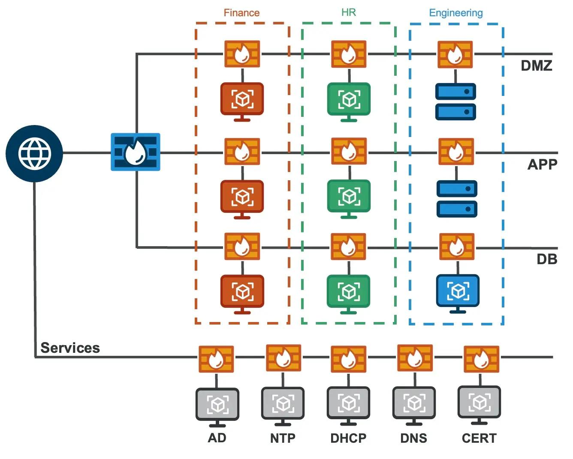

Proposed Network Architecture
Internet
|
[Edge Firewall]
|
[DMZ Network]
/ \
Web Server Mail Server
|
[Internal Firewall]
|
[Core Switch]
_________|___________
/ | \
Employee Server Management
VLAN VLAN VLAN
| |
Workstations Database

Network Segmentation
The network should be divided into separate logical zones.
Employee VLAN
Used for normal employee computers.
Server VLAN
Used for application and internal servers.
Database VLAN
Used for sensitive customer databases.
Guest VLAN
Used for visitors and personal devices.
Management VLAN
Used by authorized network administrators.
This prevents unnecessary communication between different parts of the organization.

Firewall Deployment
A Next-Generation Firewall (NGFW) should be installed at the internet boundary.
It can perform:
- Traffic filtering
- Application control
- Access control
- Malware detection
- Intrusion prevention
- Web filtering
- Logging
An additional internal firewall can protect highly sensitive database systems.

DMZ
Public-facing services should be placed in a DMZ (Demilitarized Zone).
For example:
Internet
|
Firewall
|
DMZ
|
Web Server
|
Internal Firewall
|
Internal Network
If a public web server is compromised, the attacker should not automatically gain access to internal databases.

Authentication
Strong authentication should be implemented.
Recommended methods include:
- Multi-factor authentication
- Strong passwords
- Role-Based Access Control
- 802.1X
- Least-privilege access
For example:
An employee responsible only for customer support should not automatically have administrator-level access to the banking database.

IDS/IPS
An Intrusion Detection System (IDS) monitors traffic and generates alerts when suspicious activity is detected.
An Intrusion Prevention System (IPS) can additionally block suspicious traffic.
They can help detect:
- Port scanning
- Brute-force attempts
- Malware
- Suspicious connections
- Unauthorized access
- Abnormal traffic
\
Data Protection
Sensitive financial information should be protected using:
- Encryption
- Secure VPN
- TLS for applications
- Encrypted database storage
- Secure backups
- Access logging
Data should be protected both during transmission and while stored.

Performance Considerations
Security controls should not unnecessarily affect network performance.
This can be achieved by:
- Using appropriately sized firewalls
- Applying efficient firewall rules
- Separating network traffic using VLANs
- Prioritizing critical banking applications
- Monitoring bandwidth
- Regularly reviewing network performance

Compliance
Financial organizations need strong controls over sensitive data.
The architecture supports compliance through:
- User authentication
- Access control
- Logging
- Monitoring
- Encryption
- Segmentation
- Security auditing
All access to sensitive systems should be recorded so that suspicious activity can be investigated.

Budget Consideration
The institution can reduce costs by using logical segmentation through VLANs instead of creating completely separate physical networks.
Security spending should focus on the most critical areas:
- Customer database
- Banking applications
- Internet gateway
- Authentication infrastructure
- Security monitoring
Existing switches and network infrastructure can be reused where technically suitable.

Future Scalability
The design can support future expansion through:
- Additional VLANs
- Additional servers
- More employees
- More branches
- Additional security devices
- Cloud services
The architecture does not require a complete redesign when the organization grows.

Overall Comparison
Factor | Rural Office | University | Financial Institution
Main problem | Limited internet | 3,000+ users | Sensitive data
Main technology | 4G/5G | Wi-Fi 6/6E | Segmented LAN
Primary security | VPN + Firewall | WPA3 + 802.1X | Firewall + MFA + IDS/IPS
Main concern | Reliability | Capacity | Security
Cost solution | Wireless broadband | Strategic AP placement | VLAN segmentation
Scalability | Dual-WAN | Additional APs | Additional VLANs
Key objective | Continuous connectivity | Efficient wireless access | Secure data access
Final Conclusion
The three scenarios require different network designs because their constraints are different.
For the rural branch, wireless broadband with backup connectivity provides reliable internet without expensive wired infrastructure.
For the university, Wi-Fi 6/6E, strategic AP placement, proper channel planning, and WPA3-Enterprise provide efficient connectivity for thousands of users.
For the financial institution, VLAN segmentation, firewalls, MFA, IDS/IPS, and encryption provide strong protection for sensitive financial information.
Therefore, the best network solution is not necessarily the most expensive one. It should be selected according to the organization's requirements, budget, reliability, security, performance, and future scalability.
In the third question, the financial institution has the highest security requirements because it handles sensitive customer and financial information. A segmented network architecture with VLANs, firewalls, a DMZ, multi-factor authentication, role-based access control, encryption, and IDS/IPS provides multiple layers of protection. Network segmentation limits unauthorized movement between systems, while firewalls and intrusion detection mechanisms help prevent and identify attacks. At the same time, logical segmentation and appropriate use of existing infrastructure can control operational costs.

Overall Conclusion of All Three Questions
The three constraint-based network problems demonstrate that network design should always be based on the specific requirements, limitations, and objectives of an organization. A single networking solution cannot be considered suitable for every situation because rural offices, large university campuses, and financial institutions have completely different requirements.
In the first question, the rural branch office faces the major constraint of unavailable high-speed wired internet and a limited budget. A 4G/5G wireless connection with a backup connection, supported by a firewall, VPN, secure Wi-Fi, and UPS, provides a practical solution. This design allows employees to access cloud applications, participate in video conferences, and securely communicate with headquarters. Backup connectivity improves availability and reduces the risk of business interruption. The solution can also be expanded as the branch grows.
In the second question, the university needs to provide wireless connectivity to more than 3,000 students across several buildings and high-density areas. The main challenge is not simply providing coverage, but providing sufficient capacity and performance for many simultaneous users. A centrally managed Wi-Fi 6/6E network, strategic access-point placement, proper channel planning, and the use of 5 GHz/6 GHz bands can reduce congestion and improve performance. WPA3-Enterprise, 802.1X authentication, and VLAN segmentation provide secure access while keeping student, faculty, guest, and administrative traffic separated.
In the third question, the financial institution has the highest security requirements because it handles sensitive customer and financial information. A segmented network architecture with VLANs, firewalls, a DMZ, multi-factor authentication, role-based access control, encryption, and IDS/IPS provides multiple layers of protection. Network segmentation limits unauthorized movement between systems, while firewalls and intrusion detection mechanisms help prevent and identify attacks. At the same time, logical segmentation and appropriate use of existing infrastructure can control operational costs.
Overall, the three solutions demonstrate the importance of balancing performance, reliability, security, cost, and scalability. The rural office prioritizes reliable connectivity, the university prioritizes high-density wireless performance, and the financial institution prioritizes security and controlled access.
The recommended designs also demonstrate that cost-effective networking does not necessarily mean reducing security or performance. Instead, technologies such as VPNs, VLANs, centralized management, dual-WAN connectivity, WPA3, MFA, and IDS/IPS can be selected according to the actual requirements and risks.
Therefore, effective constraint-based network design involves:
- Identifying the major requirements and limitations.
- Selecting suitable network technologies and devices.
- Providing appropriate security mechanisms.
- Ensuring reliable and efficient network performance.
- Controlling implementation and operational costs.
- Allowing the network to scale in the future.
Final Statement
In conclusion, the best network architecture is not the one with the maximum number of devices or the highest cost, but the one that satisfies the organization's requirements within its constraints. By carefully considering connectivity, bandwidth, reliability, security, cost, user capacity, and future growth, network engineers can design solutions that are efficient, secure, reliable, economical, and scalable. These three cases demonstrate how constraint-based problem solving can be applied to real-world networking environments and how appropriate technology selection can support uninterrupted and secure organizational operations.

RUBRICS FOR CALCULATION

Criteria | Weightage (%) | Exemplary (4) | Proficient (3) | Developing (2) | Beginning (1)
Understanding of Problem & Constraints | 20% | Clearly identifies all constraints and fully understands the problem requirements | Identifies most constraints with minor gaps in understanding | Identifies some constraints but misses key aspects | Shows little or no understanding of constraints or problem
Problem Decomposition | 15% | Breaks problem into logical, well-structured sub-problems effectively | Breaks problem into sub-parts with some logical flow | Attempts decomposition but lacks clarity or structure | No clear decomposition of the problem
Application of Constraints in Solution | 20% | Applies all constraints correctly and consistently in solution design | Applies most constraints correctly with minor errors | Applies some constraints but with noticeable errors | Fails to apply constraints appropriately
Logical Reasoning & Strategy | 15% | Uses strong, clear, and efficient reasoning strategies | Uses generally sound reasoning with minor gaps | Reasoning is partially correct but inconsistent | Reasoning is unclear or incorrect
Solution Accuracy & Feasibility | 15% | Solution is fully correct, feasible, and optimized | Solution is mostly correct and feasible | Solution has errors or is partially feasible | Solution is incorrect or not feasible
Creativity & Innovation | 5% | Demonstrates highly innovative and unique approach | Shows some creativity in approach | Limited creativity shown | No creativity; relies on basic or copied ideas
Clarity of Presentation | 10% | Solution is clearly presented with excellent organization and explanation | Presentation is clear with minor issues | Presentation lacks clarity or organization | Poorly presented and difficult to understand

